# Topic A, Task sourcing:

Entities, Relationships, Attributes

The system is a catalogue of tasks submitted by users. Users can either submit a task or pick a task. Tasks are general chores such washing a car on Kent Vale’s carpark on Sunday, or delivering a parcel on Tuesday between 17:00 and 19:00. Users who want to pick a task can bid. Some generic common tasks may be available for task requesters to instantiate. The user who submits a task or the system (your choice) chooses the successful bid. Each user has an account. Administrators can create, modify and delete all entries.

Please refer to www.taskrabbit.com for examples and data.

# ER Diagram

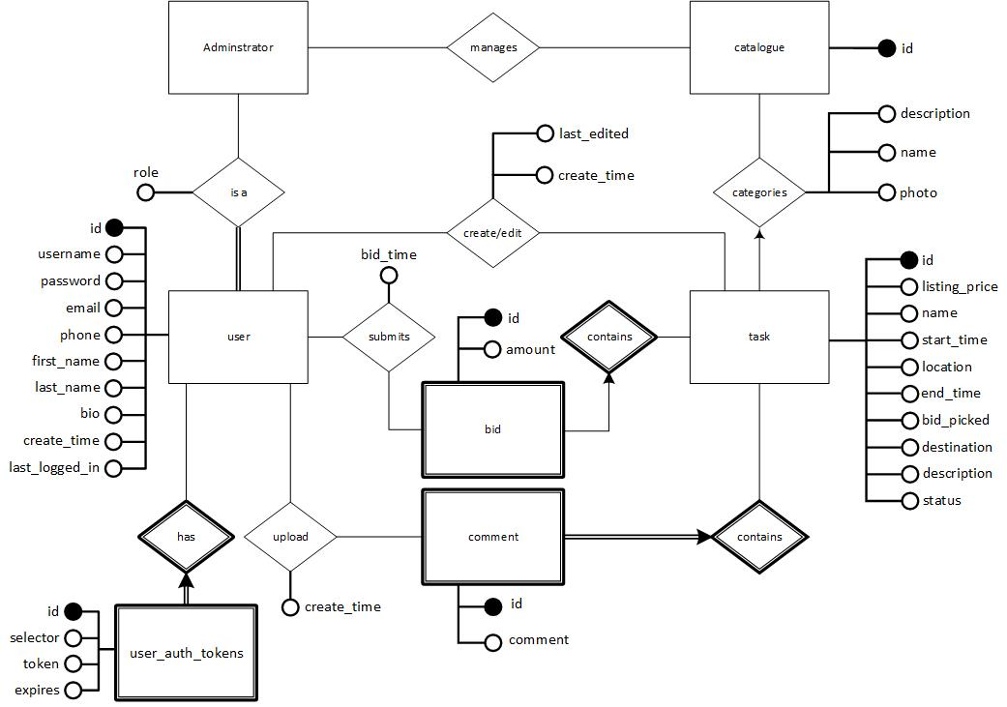

# Design Pattern

Our model uses a slightly modified form of MVC with added templates

## Model

The model is responsible for maintaining and storing of data for the application

## View

The view is responsible for generating JSON output for further processing

## Controller

The controller is responsible for handling user interactions of web pages as well as interactions with the data model objects

## Templates

The templates is responsible for the layout of the website. Dynamic data will be retrieved by the View as JSON and html will be generated through JavaScript.

# To do

|  |  |  |
| --- | --- | --- |
| **Category** | **Feature** | **Remarks** |
| Navigation Bar  (banner.php) | Link to “create new user or login” if there is no logged in user | Done |
| Show user profile when user is logged in | Done |
| On click and hover for other options like settings or view all past and current tasks user has created and/or tasks user has bid on and got/failed to get |  |
| Link to all available task page | Done |
| Search bar for quick searching | Currently in search.php |
|  | Show all current and past tasks logged-in user has completed |  |
| Searched tasks page  (search.php) | Displays results of the search function | Done |
| Search function should be able to search users and task |  |
| Make search case-insensitive |  |
| Pagination of search results |  |
| Homepage  (index.php) | Display some task to show that tasks are being bided | Partially Done (Link to task not done) |
| Text to entice users to signing up for a free account and giving it a try | Partially Done (We need better text for this) |
| User Registration page (register.php)  (MVC done) | User input form | Done |
| Form validation for all fields (Notify which fields fail)   * Username already exists (Use SQL to check) * Username blank * Password does not match * Email validation * Phone validation * Server Side validation |  |
| Form should still contain filled in information upon failed validation | Done |
| Logout page (logout.php)  (MVC done) | Log out and redirect to home page | Done |
| Login page  (login.php)  (MVC done) | Form for username/password  Validate required fields  Server side validation | Done |
| Use cookies to store login information so users can ‘remember me’ | Done |
| Link to registration page | Done |
| User profile  (profile.php) | Contains user information with the option to edit personal info and update | Partially Done (No profile picture) |
| Change password function |  |
| All Tasks page  (task.php) | Show all tasks with pagination | Partially Done (Pagination not done) |
| Filter by category/name/etc. |  |
| Show tasks that the user has created | Partially Done |
| Admin should be able to delete task on this page |  |
| Task creation page  (task.php) | Menu to select category of task with links to details | Done |
| Form to enter task details | Partially Done (Uploading of images not done) |
|  | Form validation   * Ensure start datetime < end datetime * Please add more |  |
| Task details/bidding/selection  (task_details.php) | Display all task details | Done |
| Show other bids (Include username and profile photo if any) | Partially Done (No user photo yet) |
| Show comments for the task (Include username and profile photo if any) | Partially Done (No user photo yet) |
| Has a “Bid on task” for user to bid for a task directly | Done |
| Shows the user’s bid on the task and remind the user will be contacted if they get the task. | Partially Done (User not contactable at the moment) |
|  | Allow user to modify their bid if their bid has not been selected | Done |
|  | Users/Owner should be able to comment on a specific task | Done |
|  | Users/Owner should be able to delete their own comment. |  |
|  | Owner should be able to edit/delete/close(confirm) the task |  |
|  | Owner should be able to select a bid from the list | Partially done (Selecting the bid does nothing at the moment) |
|  | When a task is edited, users that bid for the task must be notified |  |
|  | Admins should be able to edit/delete any bid/comment/task |  |
| Statistics  (statistics.php) | Show number of users with the highest number of acceptance rates |  |
| Show users that have bided for all tasks in a category |  |
|  | Show users with highest/lowest bids |  |
| Others | MVC Model |  |
|  | Index proper columns to allow faster searching |  |
|  | Add photos for dummy data tasks (Use default photo if none specified) |  |
|  | Add more dummy data to make the website look populated |  |